Appendix

Host Channel Transfer Size Register:
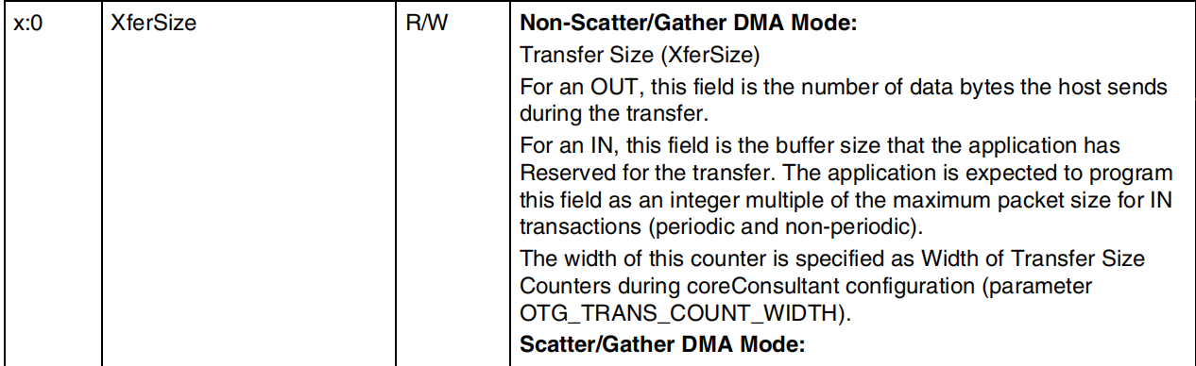

IO sequences with Babble Error:
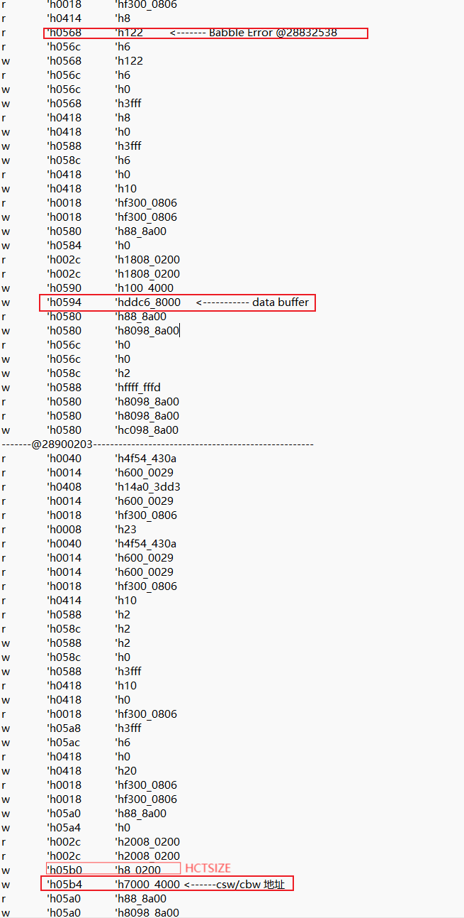

data packets without Babble Error:
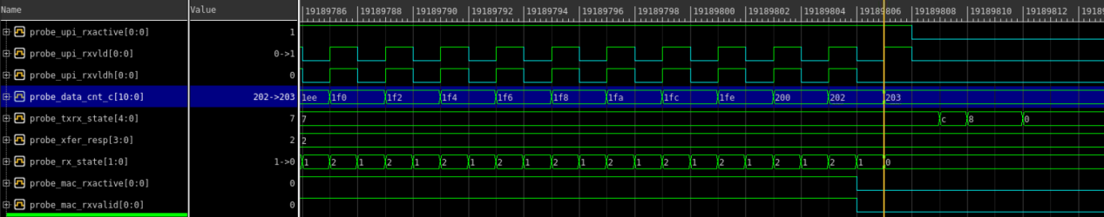
data packets with Babble Error (The device sent an extra packet204):
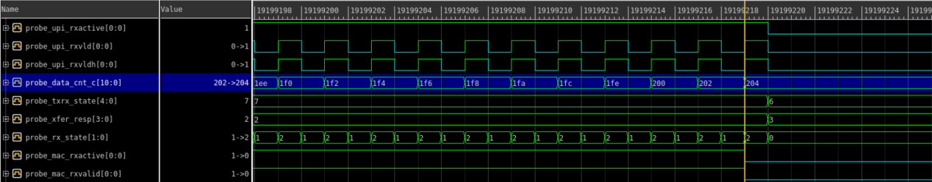

CSW buffer data through DMA write(0x70004000-0x7000400c) under normal circumstances:

CSW buffer data through DMA write(0x70004000-0x700041fc) after Babble Error:

Email content
Of course, when the USB device and host are transmitting normally, us->iobuf size is 64, which is enough for CBW/CSW and there will be no problem.

Howerver, we encountered a problem in the FPGA verification environment, that is, the DWC otg controller detected a Babble Error, and we believe that the processing flow of the device driver will cause the risk of us->iobuf overflow. Regarding USB Babble Error, the DWC_otg_programming manual describes it as follows:
3.8.1 Handling Babble Conditions
DWC_otg handles two cases of babble: packet babble and port babble. Packet babble occurs if the device sends more data than the maximum packet size for the channel. Port babble occurs if the controller continues to receive data from the device at EOF2 (the end of frame 2, which is very close to SOF).
When DWC_otg detects a packet babble, it stops writing data into the Rx buffer and waits for the end of packet (EOP). When it detects an EOP, it flushes already-written data in the Rx buffer and generates a Babble interrupt to the application

When the usb_stor_bulk_transport interface calls usb_stor_bulk_srb for data transmission (such as the SCSI layer 120K data read request), the controller detects a Babble Error and enters the interrupt processing function dwc2_hc_babble_intr, which eventually parses the data stage transmission result of the BOT as USB_STOR_XFER_LONG, and also halts the transmission channel. However, the USB device does not know that a Babble Error has occurred at this time.

In order to ensure the integrity of the BOT transfer , the usb_stor_bulk_transfer_buf interface is called for status stage transmission(as the comments say: get CSW for device status), and an IN transfer transaction is requested: HCTSIZ register value of the host channel transmission is configured to be 512 bytes, and the DMA address is 0x7000_4000 (CBW/CSW address, see the appendix document). Under normal circumstances, the device should return 13 bytes.

However, what we observed is 512 bytes are actually returned (see the appendix document). According to our analysis, when a Babble Error occurs, the device will continuously return data.

According to the mass storage driver flow, software will parse the data header 13 bytes, which is not the expected CSW format. It is considered that the complete BOT transfer result is USB_STOR_XFER_ERROR, and the SCSI layer result is returned as DID_ERROR. The usb_stor_invoke_transport interface will initiate a port reset, that is, usb_stor_port_reset, to notify the device that a problem has occurred, then device will enter the enumeration process.

